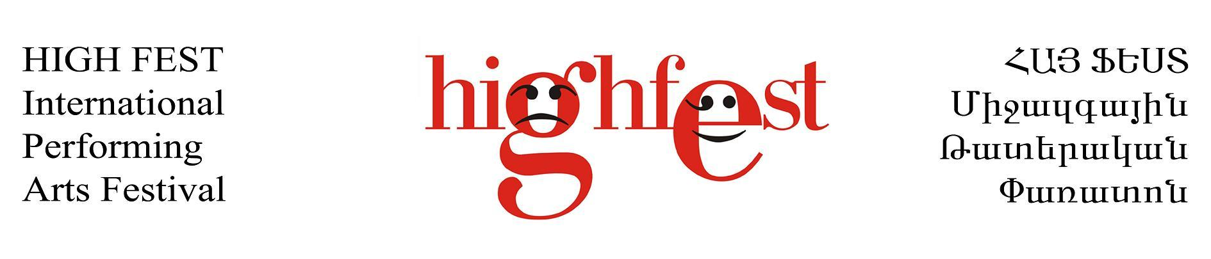

HIGH FEST International Performing Arts Festival
Main festival in the countries of the former USSR (outside of Moscow)
1 – 8 October 2020 / Yerevan, Armenia
(Seventeen Edition)
Application deadline – March 15th, 2020

We are pleased to inform, that the HIGH FEST International Performing Arts Festival welcomes performing arts companies and artists to present their productions in all genres of performing arts including theatre (drama, comedy, mime, movement, circus, street performances, puppet/marionette, fingers theatre, visual etc.), dance (contemporary, modern ballet, folk, classic etc.), music (opera, classical, musical, contemporary, jazz, folk etc) and other forms of performing arts.
Here are our Programmes, which will be held in the framework of the Festival:
*Main program
*Fringe Program
*ARMS FEST - Armenian International Student and Youth Program;

Note!!! If your work is out of the format of the festival or the deadline has already passed, we can offer you to participate at the Fringe Program which means you take care of all your expenses (including travel, accommodation, meals, technical costs, venue rent) and pay the participation fee (200 Euro). The Organizing Committee provides to/from airport local transport, marketing and publicity costs, as well as free access to all performances and connected events.

If you are interested in participating at the HIGH FEST 2020, please read carefully the information below and send the application form and the info pack till the March 15th 2020 to the following address:
HIGH FEST International Performing Arts Festival
Yerevan State Institute of Theatre and Cinema
Amiryan 26
Yerevan 0002
Armenia

Application form (in English)

1. Full name of the theatre / company’s history (up to 500 words);
2.Choose the festival program you are applying to:
• Main Program;
• Fringe Program;
• Student/Youth Performances (ARMS FEST);

3. City / Country;
4. Performance title, short description (up to 500 words);
5. Genre, number of acts;
6. Venue size, approx. number of spectators
7. Director/Choreographer, performers;
8. List of previous festivals the applying production participated at;
9. Number and names of arriving people (actors and others);

Nr. | Function within the group | Name | Last Name | Gender  M/F | Citizenship
10. Duration of the play;
11. Language of the performance (if any);
11. Weight of decorations, dimensions, need in transport;
12. Technical conditions necessary for the show: stage size, time required for stage set up and break down, light/sound equipment etc.;
13. Preferable dates to perform at the festival;
14. Information (address, fax, landline, mobile, website, Email). Contact person.
For selection process we need information pack, photos (good resolution / quality if digital) and full length video
A first selection will be established and the selected companies will be asked to send more information and confirm their availability.

Application process

- The application deadline is the 15th of March.
- You will receive a confirmation from us as soon as we receive your application and info pack. If you do not receive a confirmation, please inform us.
- From the 15th of March till the 1st of May, you will be informed about the Advisory Board’s decision.
- You need to confirm your participation till 30th of June. As soon as we receive your confirmation, we will send you the official invitation.

Conditions of participation
The selection for HIGH FEST 2020 is mainly based on the following criteria:
• Shows of the high quality and professionalism
• Shows and performances of all genres of performing arts; preferable not exceeded 5-7 person
• Companies ready to take part in workshops, meetings and discussions;
• Companies ready to work together with the festival organizers to make things possible;
So…
• Each company will actively participate in workshops, master classes and meetings with famous theatre practitioners;
• Each Company will perform once or two times;
• Each Company will be able to see the work of other invited artists and to make new contacts.

The conditions
The Organizing Committee provides the following:
• Accommodation (max 3 nights) and 2 meals per day;
• Free access to all Festival events / performances etc;
• There is possibility of giving a modest fee to some companies chosen by Organizing Committee
• Local transportation from and to airport
• Technical and administrative costs;
• Press, marketing and publicity costs;
• Place at the festival catalogue and programme
• Participation certificate, if necessary.

The companies are responsible for their expenses of travel, visa aprox. 6- 8 Euros (at the Yerevan airport upon-arrival).

Contact us at:
Address: Amiryan 26, Yerevan State Institute of Theatre and Cinema, Yerevan 0002, Armenia
Tel: +374 99 53 62 33 (whatsapp / viber)
E-mail: info@highfest.am
Web: www.highfest.am

